**WALCHAND COLLEGE OF ENGINEERING, SANGLI**

**DEPARTMENT OF COMPUTER SCIENCE AND ENGINEERING**

**LA4/ESE SCHEDULE (POE)**

**COURSE: PROGRAMMING LABORATORY-3 (4CS354)**

**CLASS: TY CSE**

**DATE & TIME: 01/01/2021, FRIDAY, 3.30 PM TO 5.30 PM**

------------------------------------------------------------------------------------------------

Exam Seat Number: **2018BTECS00071 ( T-5 Batch )**

Name: **Narkhede Saurabh Makarand**

Problem Statement: **Design a website for Student Welfare with following objectives**:  
 Index Home Page that shows list of schemes available for students  
 At least 3 pages, each for a separate detailed scheme with related image  
 Apply option for each scheme  
 When clicked on Apply, user should fill registration form consider full name, college name, state, id proof, password, class, Year.

**Screen Shots:**

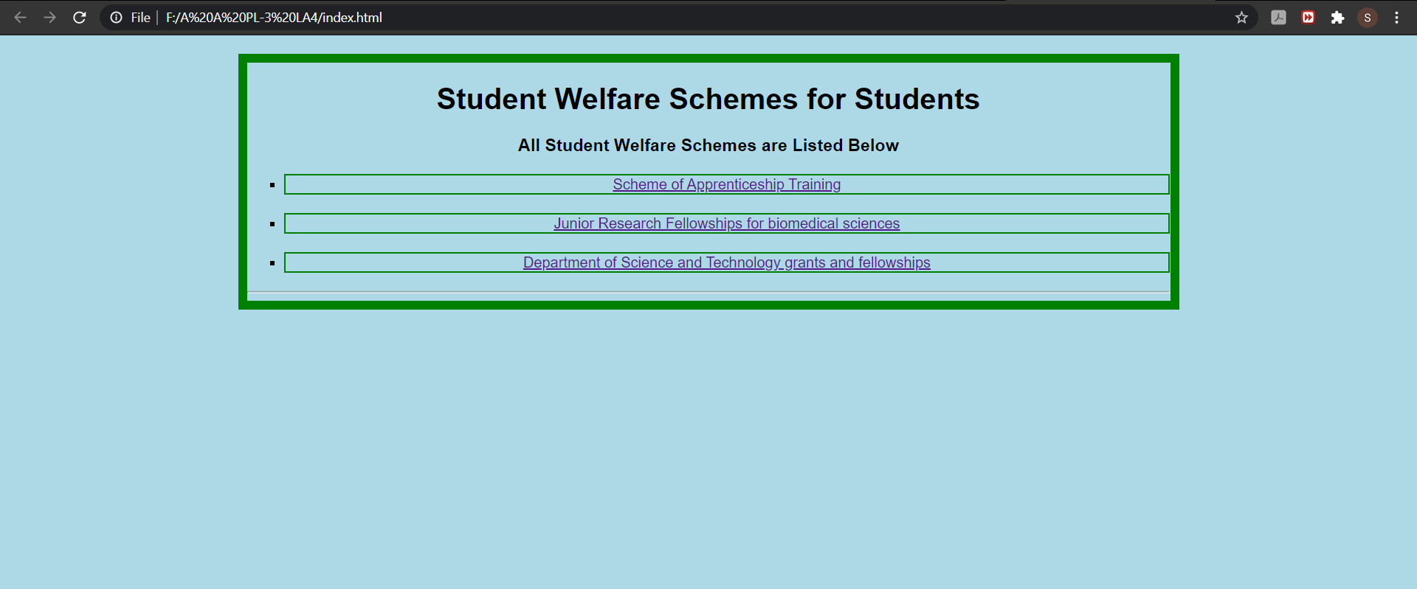



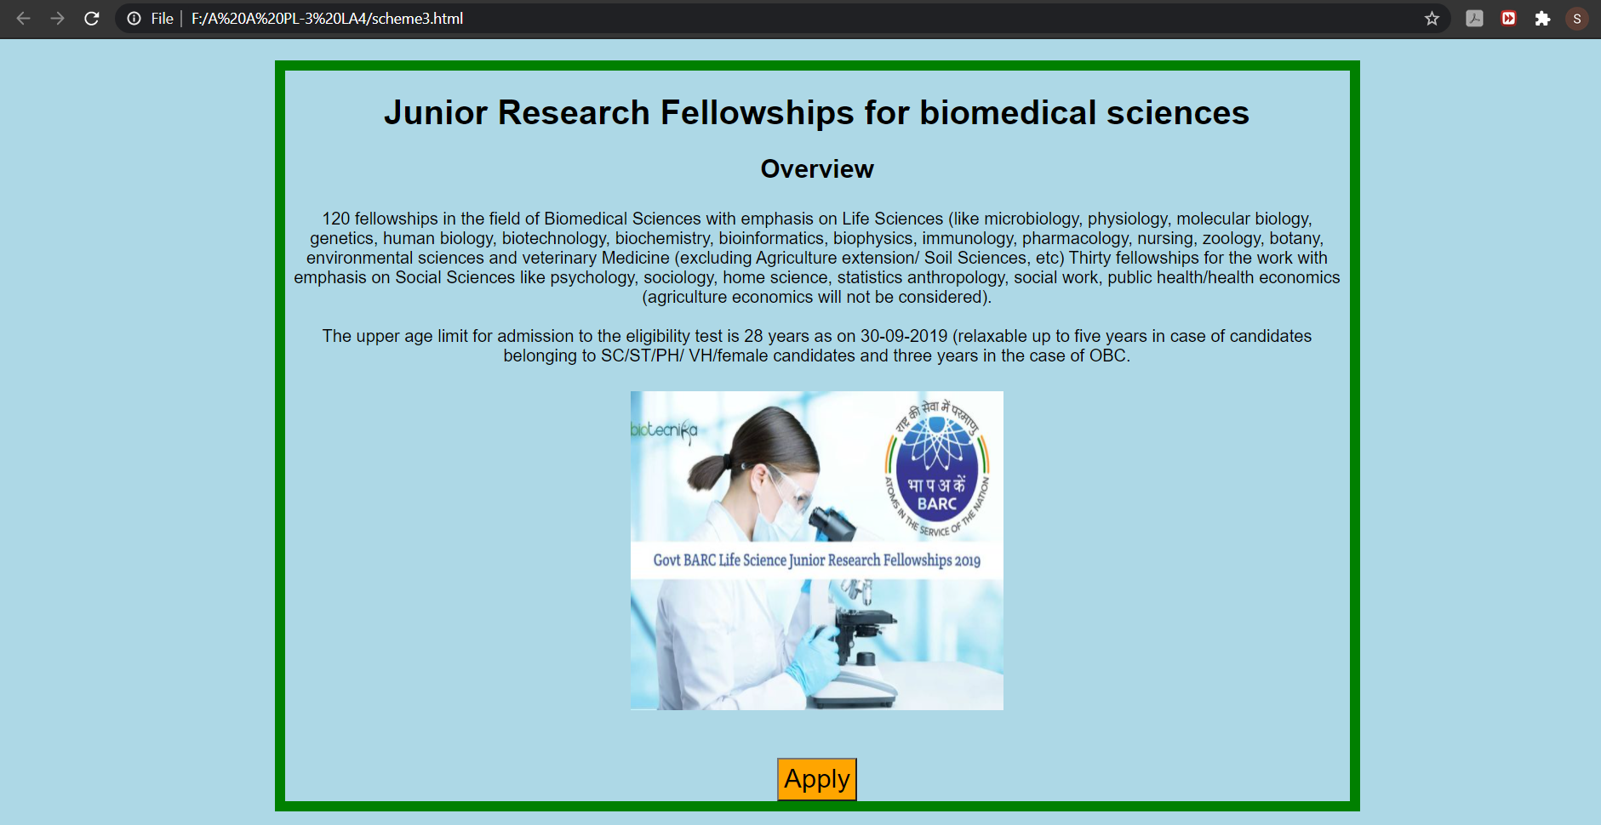

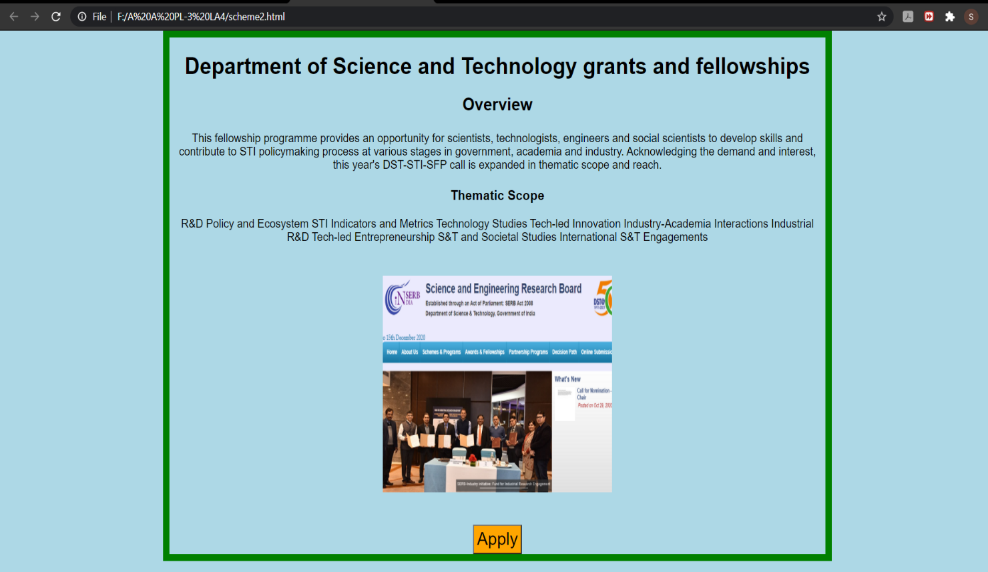

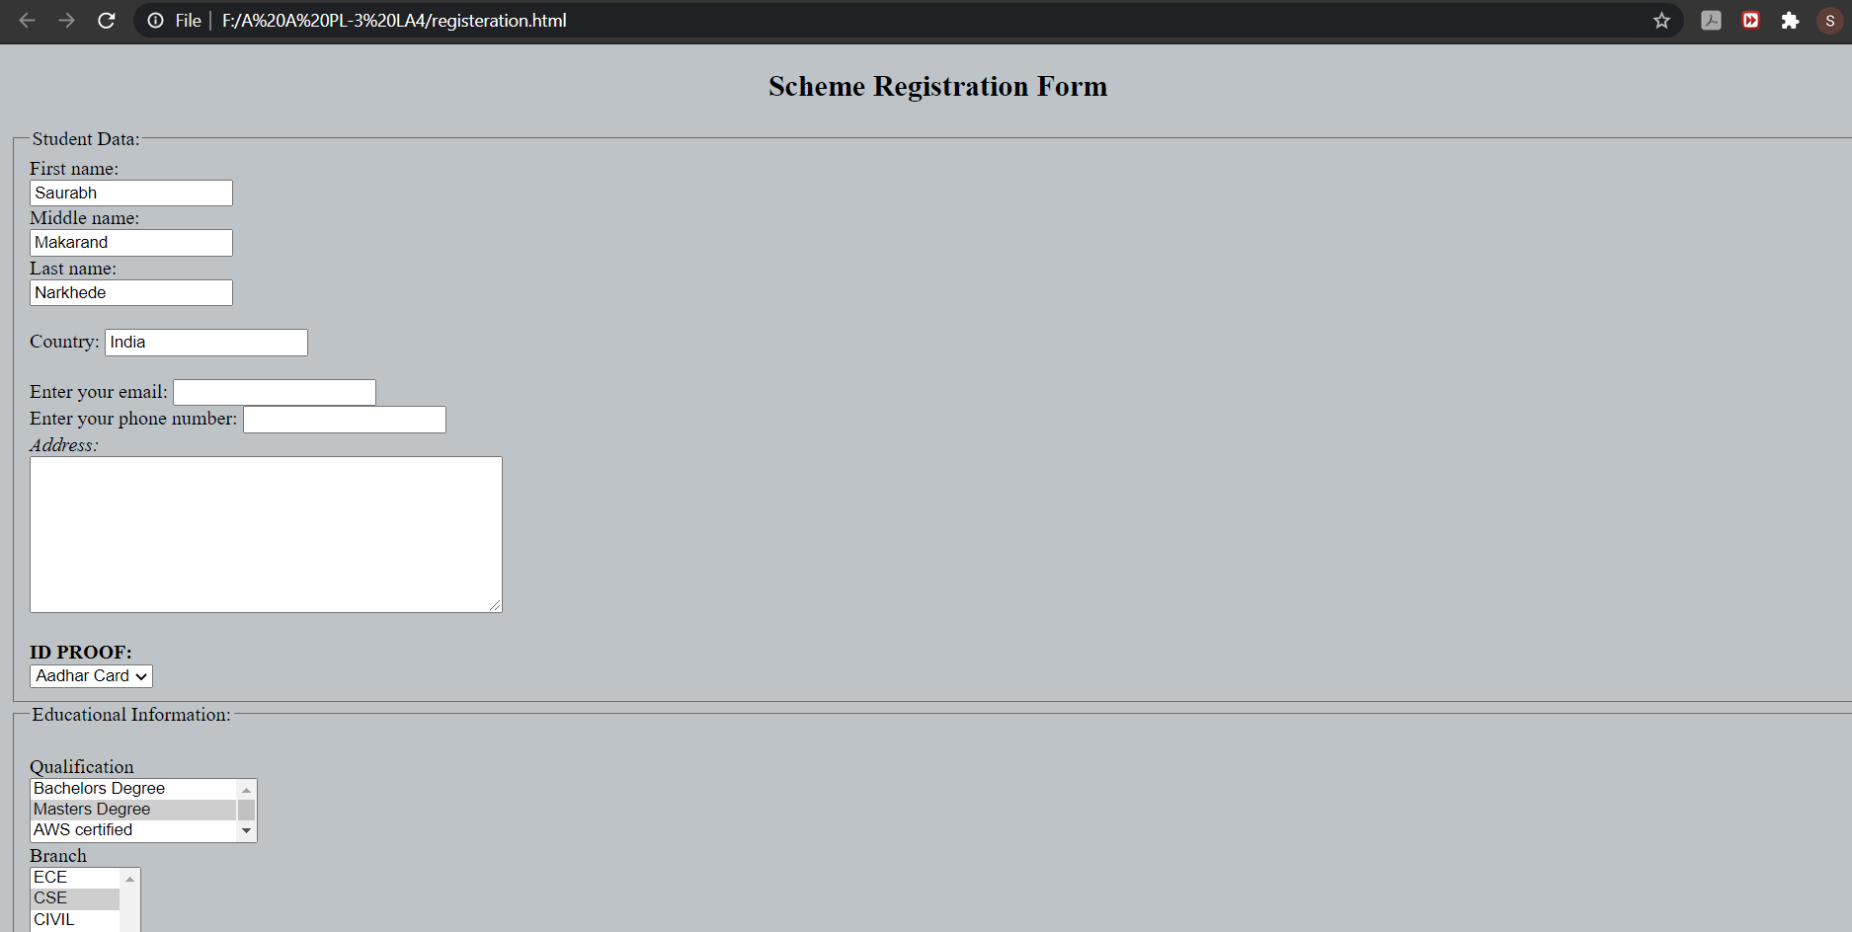

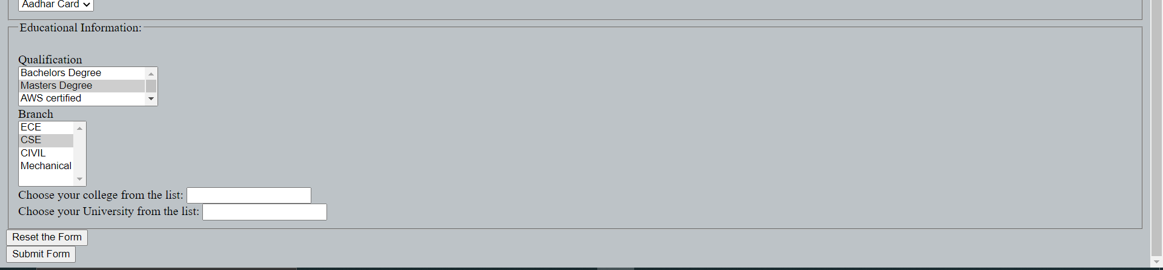

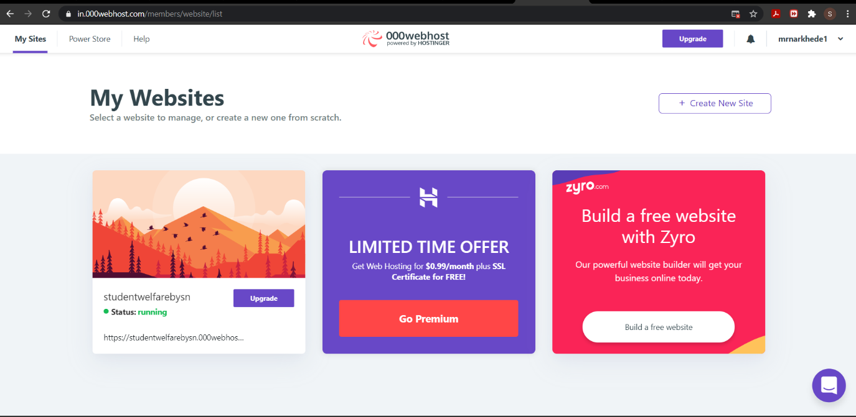

**GitHub Link:**

**Hosting Link:**